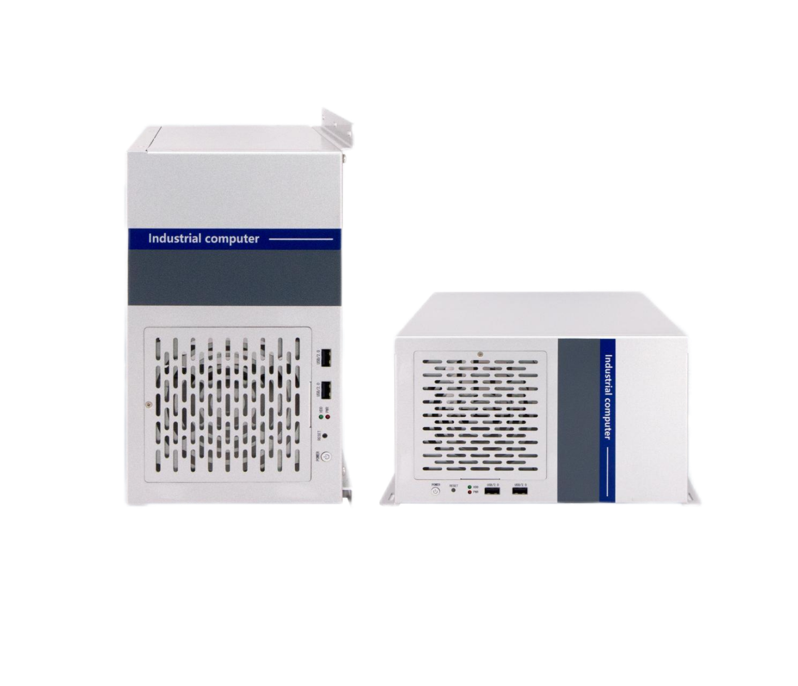
Industrial Computer
QY-U350

Products Features:
- Industrial-Grade Industrial Computer
- Support ATX / Micro-ATX / Mini-ITX Mother Board
- Intel 4/6/7/8/9/10/11/12/13/14th-i3/i5/i7/i9 desktop CPU
- Standard ATX power, 300w to 1300w
- More expansion slots, Mini PCIE / M.2 / PCIE / PCI
- Support remote power on and off
- -30℃~70℃ Temperature Can Keep 24/7 Work Stably
- Anti-Static, Anti-Pulse, Anti-Surge, Anti-Radiation
QY-U350
1-1.H81 Mother Board Specification:
Mother Board Model | QY-H8134-X
Chipset | Intel H81, Support Intel Core 4th-i3/i5/i7 / Pentium / Celeron desktop CPU, LGA 1150
Memory | Support DDR3-1333 / 1600 MHz, 2*DIMM Slots, Up to 16GB
Storage | 1*MSATA SSD slot  1*SATA 3.0+2*SATA 2.0 slots
Display | 1*DVI: Resolution max up to 1920*1200@60Hz  1*VGA: Resolution max up to 1920*1200@60Hz
Expansion | 1*PCIE 16x slot+1*PCIE 4x slot+1*PCIE 1x slot  4*PCI slots
Ethernet | 2*Intel I210 GbE LAN Chip (10 / 100 / 1000 Mbps, RJ-45 Type)
USB | 2*USB 3.0 (Type-A)  2*USB 2.0 (Type-A)  6*USB 2.0 (Header)
COM | 1*RS-232 / 485 (DB9 type)  5*RS-232 (DB9 type)
Audio | 1*Line-out+1*Line-in+MIC
Mother Board Type | ATX

QY-U350
1-2.B85 Mother Board Specification:
Mother Board Model | QY-B85-ATX-V11
Chipset | Intel B85, Support Intel Core 4th-i3/i5/i7 / Pentium / Celeron desktop CPU, LGA 1150
Memory | Support DDR3-1333 / 1600 MHz, 2*SO-DIMM Slots, Up to 16GB
Storage | 1*MSATA SSD slot  4*SATA 3.0 slots
Display | 1*DP: Resolution max up to 2560*1440@60Hz  1*HDMI: Resolution max up to 2560*1440@60Hz  1*VGA: Resolution max up to 1920*1080@60Hz
Expansion | 1*PCIE 16x slot+2*PCIE 4x slots  2*PCI slots  1*Mini PCIE slot, support 4G and WIFI module
Ethernet | 2*Intel 1Gbps LAN Chip (10 / 100 / 1000 Mbps, RJ-45 Type)
USB | 4*USB 3.0 (Type-A)  3*USB 2.0 (Type-A)  8*USB 2.0 (Header)
COM | 1*RS-232 / 422 / 485 (DB9 type)  1*RS-232 / 485 (DB9 type)  4*RS-232 (DB9 type)
Audio | 1*Line-out+1*MIC
Mother Board Type | Micro-ATX

Mother Board Model | QY-F1162-A-H
Chipset | Intel H110, Support Intel Core 6/7/8/9th-i3/i5/i7 / Pentium / Celeron desktop CPU, LGA 1151
Memory | Support DDR4-2133/2400/2600 MHz, 2*U-DIMM Slots, Up to 128GB
Storage | 1*MSATA SSD slot  4*SATA 3.0 slots
Display | 1*DVI: Resolution max up to 1920*1200@60Hz  1*VGA: Resolution max up to 1920*1200@60Hz  1*HDMI: Resolution max up tp 1920*1080@60Hz
Expansion | 1*PCIE 16x slot+1*PCIE 4x slot+1*PCIE 1x slot  4*PCI slots  1*Mini PCIE slot, support 4G and WIFI module
Ethernet | 2*Intel (i210V+i219V) LAN Chip (10 / 100 / 1000 Mbps, RJ-45 Type)
USB | 4*USB 3.0 (Type-A)  2*USB 2.0 (Type-A)  3*USB 2.0 (Header)
COM | 2*RS-232 / 485 (DB9 type)  4*RS-232 (DB9 type)
Audio | 1*Line-out+1*Line-in+1*MIC
Mother Board Type | ATX
1-3.H110 Mother Board Specification:
QY-U350

Mother Board Model | QY-Z3932-X
Chipset | Intel Z390, Support Intel Core 6/8/9th-i3/i5/i7 / Pentium / Celeron desktop CPU, LGA 1151
Memory | Support DDR4-2666 MHz, 2*Non-ECC U-DIMM Slots, Up to 64GB
Storage | 1*M.2 NVME/SATA SSD slot  4*SATA 3.0 slots
Display | 1*DVI: Resolution max up to 1920*1200@60Hz  1*VGA: Resolution max up to 1920*1200@60Hz  1*HDMI: Resolution max up to 14096*2160@30Hz
Expansion | 1*PCIE 16x slot+1*PCIE 4x slot  2*PCI slots  1*Mini PCIE slot, support 4G and WIFI module
Ethernet | 2*Intel (i219V+i225V) LAN Chip (10 / 100 / 1000 / 2500 Mbps, RJ-45 Type)
USB | 4*USB 3.2 (Type-A)  2*USB 2.0 (Type-A)  5*USB 2.0 (Header)
COM | 1*RS-232 / 422 / 485 (DB9 type)  1*RS-232 / 485 (DB9 type)  4*RS-232 (DB9 type)
Audio | 1*Line-out+1*Line-in+1*MIC
Mother Board Type | Micro-ATX
QY-U350
1-4.Z390 Mother Board Specification:

Mother Board Model | QY-F1762-H
Chipset | Intel Q170, Support Intel Core 6/7/8/9th-i3/i5/i7 / Pentium / Celeron desktop CPU, LGA 1151
Memory | Support DDR4-2133/2400/2600 MHz, 4*U-DIMM Slots, Up to128GB
Storage | 1*MSATA SSD slot  3*SATA 3.0 slots  1*M.2 NVME SSD slot
Display | 1*DVI: Resolution max up to 1920*1200@60Hz  1*VGA: Resolution max up to 1920*1200@60Hz  1*HDMI: Resolution max up to 3840*2160@30Hz
Expansion | 2*PCIE 16x slots+2*PCIE 4x slots+1*PCIE 1x slot  2*PCI slots  1*Mini PCIE slot, support 4G and WIFI module
Ethernet | 2*Intel 1Gbps LAN Chip (10 / 100 / 1000 Mbps, RJ-45 Type)
USB | 6*USB 3.0 (Type-A)  8*USB 2.0 (Header)
COM | 1*RS-232 / 422 / 485 (DB9 type)  1*RS-232 / 485 (DB9 type)  4*RS-232 (DB9 type)
Audio | 1*Line-out+1*Line-in+1*MIC
Mother Board Type | ATX
1-5. Q170 Mother Board Specification:
QY-U350

Mother Board Model | QY-H4734-X
Chipset | Intel H470, Support Intel Core 10th-i3/i5/i7/i9 / Pentium / Celeron desktop CPU, LGA 1200
Memory | Support DDR4-2133/2400/2666/2933 MHz, 2*U-DIMM Slots, Up to 64GB
Storage | 1*M.2 SATA SSD slot  3*SATA 3.0 slots
Display | 1*DVI: Resolution max up to 1920*1200@60Hz  1*VGA: Resolution max up to 1920*1200@60Hz  1*HDMI: Resolution max up to 4096*2160@30Hz
Expansion | 1*PCIE 16x slot+2*PCIE 4x slots  4*PCI slots  1*M.2 Key-E slot, support 4G and WIFI module
Ethernet | 2*Intel (i219V+225V) LAN Chip (10 / 100 / 1000 / 2500 Mbps, RJ-45 Type)
USB | 6*USB 3.0 (Type-A)  2*USB 3.0 (Header)  5*USB 2.0 (Header)
COM | 2*RS-232 / 485 (DB9 type)  4*RS-232 (DB9 type)
Audio | 1*Line-out+1*Line-in+1*MIC
Mother Board Type | ATX
QY-U350
1-6.H470 Mother Board Specification:
QY-U350
1-7.Q470 Mother Board Specification:
Mother Board Model | QY-Q4752A-X
Chipset | Intel Q470, Support Intel Core 10/11th-i3/i5/i7/i9 / Pentium / Celeron desktop CPU, LGA 1200
Memory | Support DDR4-2400/2600/2933 MHz, 4*Non-ECC U-DIMM Slots, Up to 128GB
Storage | 1*M.2 NVME / SATA SSD slot  4*SATA 3.0 slots, Support RST RAID 0,1,5,10
Display | 1*DVI-D: Resolution max up to 1920*1200@60Hz  1*VGA: Resolution max up to 1920*1200@60Hz  1*HDMI: Resolution max up to 4096*2160@30Hz
Expansion | 2*PCIE 16x slots+3*PCIE 4x slots  2*PCI slots  1*Mini PCIE slot, support WIFI and 4G module
Ethernet | 2*Intel (I219+I211) 1Gbps LAN Chip (10 / 100 / 1000 Mbps, RJ-45 Type)
USB | 4*USB 3.0 (Type-A)  2*USB 3.0 (Header)  2*USB 2.0 (Type-A)  5*USB 2.0 (Header)
COM | 1*RS-232 / 422 / 485 (DB9 type)  1*RS-232 / 485 (DB9 type)  4*RS-232 (DB9 type)
Audio | 1*Line-out+1*Line-in+1*MIC
Mother Board Type | ATX

1-8.H610-DDR 4 Mother Board Specification:
Mother Board Model | QY-F6162-A-H-DDR 4
Chipset | Intel H610, Support Intel Core 12/13/14th-i3/i5/i7/i9 / Pentium / Celeron desktop CPU, LGA 1700
Memory | Support DDR4-3200 MHz, 2*U-DIMM Slots, Up to 64GB
Storage | 1*M.2 SATA SSD slot  3*SATA 3.0 slots
Display | 1*DVI: Resolution max up to 1920*1200@60Hz  1*VGA: Resolution max up to 1920*1200@60Hz  1*HDMI: Resolution max up to 4096*2160@30Hz
Expansion | 1*PCIE 16x slot+3*PCIE 4x slots  3*PCI slots  1*Mini PCIE slot, support 4G and WIFI module
Ethernet | 2*Intel (i219+i255) LAN Chip (10 / 100 / 1000 / 2500 Mbps, RJ-45 Type)
USB | 4*USB 3.0 (Type-A)  2*USB 2.0 (Type-A)  4*USB 2.0 (Header)
COM | 2*RS-232 / 485 (DB9 type)  4*RS-232 (DB9 type)
Audio | 1*Line-out+1*Line-in+1*MIC
Mother Board Type | ATX
QY-U350
Mother Board Model | QY-F6162-A-H-DDR 5
Chipset | Intel H610, Support Intel Core 12/13/14th-i3/i5/i7/i9 / Pentium / Celeron desktop CPU, LGA 1700
Memory | Support DDR5-4800 MHz, 2*U-DIMM Slots, Up to 64GB
Storage | 1*M.2 SATA SSD slot  4*SATA 3.0 slots
Display | 1*DVI: Resolution max up to 1920*1200@60Hz  1*DP: Resolution max up to 7680*4320@60Hz  1*HDMI: Resolution max up to 4096*2160@30Hz
Expansion | 1*PCIE 16x slot+2*PCIE 4x slots  4*PCI slots  1*Mini PCIE slot, support 4G and WIFI module
Ethernet | 2*Intel 1Gbps LAN Chip (10 / 100 / 1000 Mbps, RJ-45 Type)
USB | 4*USB 3.0 (Type-A)  7*USB 2.0 (Type-A)  2*USB 2.0 (Header)
COM | 1*RS-232 / 422 / 485 (DB9 type)  1*RS-232 / 485 (DB9 type)  4*RS-232 (DB9 type)
Audio | 1*Line-out+1*Line-in+1*MIC
Mother Board Type | ATX
QY-U350
1-9.H610-DDR 5 Mother Board Specification:

Mother Board Model | QY-F6762-A-H
Chipset | Intel Q670, Support Intel Core 12/13/14th-i3/i5/i7/i9 / Pentium / Celeron desktop CPU, LGA 1700
Memory | Support DDR5-4800 MHz, 4*U-DIMM Slots, Up to 128GB
Storage | 1*M.2 NVME SSD slot  4*SATA 3.0 slots
Display | 1*DVI: Resolution max up to 1920*1200@60Hz  1*VGA: Resolution max up to 1920*1200@60Hz  1*HDMI: Resolution max up to 4096*2160@24Hz  1*DP: Resolution max up to 7680*4320@60hz
Expansion | 2*PCIE 16x slots+3*PCIE 4x slots  2*PCI slots  1*Mini PCIE slot, support 4G and WIFI module
Ethernet | 2*Intel 1Gbps LAN Chip (10 / 100 / 1000 Mbps, RJ-45 Type)
USB | 8*USB 3.0 (Type-A)  2*USB 2.0 (Type-A)  2*USB 2.0 (Header)
COM | 1*RS-232 / 422 / 485 (DB9 type)  1*RS-232 / 485 (DB9 type)  4*RS-232 (DB9 type)
Audio | 1*Line-out+1*Line-in+1*MIC
Mother Board Type | ATX
QY-U350
1-10.Q670 Mother Board Specification:
QY-U350
1-11.Q870 Mother Board Specification:
Mother Board Model | QY-Q8762-X
Chipset | Intel Q870, Support Intel Core Ultra (Series-2) desktop CPU, LGA 1851
Memory | Support DDR5-4800 MHz, 4*U-DIMM Slots, Up to 192GB
Storage | 1*M.2 NVME SSD slot  4*SATA 3.0 slots
Display | 1*VGA: Resolution max up to 1920*1200@60Hz  1*HDMI: Resolution max up to 4096*2160@24Hz  1*DP: Resolution max up to 4096*2106@60hz
Expansion | 2*PCIE 16x slots+4*PCIE 4x slots  1*PCI slot  1*M.2 Key-E slot, support WIFI module
Ethernet | 2*Intel 1Gbps LAN Chip (10 / 100 / 1000 Mbps, RJ-45 Type)
USB | 4*USB 3.2 Gen1 (Type-A)  2*USB 3.2 Gen2 (Type-A)  7*USB 2.0 (Header)
COM | 1*RS-232 / 422 / 485 (DB9 type)  1*RS-232 / 485 (DB9 type)  4*RS-232 (DB9 type)
Audio | 1*Line-out+1*Line-in+1*MIC
Mother Board Type | ATX

QY-U350
2.Device Specification:
Power Input | ATX Power or Redundant Power Module (300w / 500w / 800w / 1000w / 1300w)
Power Input | Support Auto-Start
Working Temperature | -30℃~70℃, Support 24/7 Working
Structure | Fully Enclosed Aluminum Alloy Material
Heat Dissipation | Fan Design
Installation | Desktop / Embedded
Size | 375mm*325.2mm*175mm
System | Windows and Linux
Mother Board Type | Support ATX / Micro-ATX / Mini-ITX
GPU | Support

QY-U350
3.Ordering Information:

Note：Please contact our sales staff if you require other chipsets.
Model | Chipset | CPU | LAN | USB | COM | RAM | Display | SSD | Expansion
QY-U350 | H81 | 4th | 2 | 2*3.0  8*2.0 | 1*RS-232/485  5*RS-232 | 2*DDR 3  Up to 16GB | 1*DVI  1*VGA | 1*MSATA  3*SATA | 1*Mini PCIE  1*PCIE 16x  1*PCIE 4x  1*PCIE 1x  4*PCI
QY-U350 | B85 | 4th | 2 | 4*3.0  7*2.0 | 2*RS-232/422/485  4*RS-232 | 2*DDR 3  Up to 16GB | 1*VGA  1*HDMI  1*DP | 1*MSATA  4*SATA | 1*Mini PCIE  1*PCIE 16x  1*PCIE 4x  2*PCI
QY-U350 | H110 | 6th/7th/8th/9th | 2 | 4*3.0  11*2.0 | 1*RS-232/422/485  1*RS-232/485  4*RS-232 | 2*DDR 4  Up to 128GB | 1*VGA  1*DVI  1*HDMI | 1*MSATA  4*SATA | 1*Mini PCIE  1*PCIE 16x  2*PCIE 4x  4*PCI
QY-U350 | Z390 | 6th/8th/9th | 2 | 4*3.2  7*2.0 | 1*RS-232/422/485  1*RS-232/485  4*RS-232 | 2*DDR 4  Up to 64GB | 1*VGA  1*DVI  1*HDMI | 1*M.2  4*SATA | 1*Mini PCIE  1*PCIE 16x  1*PCIE 4x  2*PCI
QY-U350 | Q170 | 6th/7th/8th/9th | 2 | 6*3.0  8*2.0 | 1*RS-232/422/485  1*RS-232/485  4*RS-232 | 4*DDR 4  Up to 128GB | 1*DVI  1*HDMI  1*VGA | 1*M.2  1*MSATA  4*SATA | 1*Mini PCIE  2*PCIE 16x  3*PCIE 4x  2*PCI
QY-U350 | H470 | 10th | 2 | 8*3.0  5*2.0 | 2*RS-232/485  4*RS-232 | 2*DDR 4  Up to 64GB | 1*DVI  1*HDMI  1*VGA | 1*M.2  3*SATA | 1*M.2  1*PCIE 16x  1*PCIE 4x  4*PCI
QY-U350 | Q470 | 10th/11th | 2 | 6*3.0  7*2.0 | 1*RS-232/422/485  1*RS-232/485  4*RS-232 | 4*DDR 4  Up to 128GB | 1*DVI  1*HDMI  1*VGA | 1*M.2  4*SATA | 1*Mini PCIE  2*PCIE 16x  3*PCIE 4x  2*PCI
QY-U350 | H610  DDR 4 | 12th/13th/14th | 2 | 4*3.0  7*2.0 | 2*RS-232/485  4*RS-232 | 2*DDR 4  Up to 64GB | 1*DVI  1*HDMI  1*VGA | 1*M.2  3*SATA | 1*Mini PCIE  1*PCIE 16x  3*PCIE 4x  3*PCI
QY-U350 | H610  DDR 5 | 12th/13th/14th | 2 | 4*3.0  9*2.0 | 1*RS-232/422/485  1*RS-232/485  4*RS-232 | 2*DDR 5  Up to 64GB | 1*DP  1*HDMI  1*VGA | 1*M.2  4*SATA | 1*Mini PCIE  1*PCIE 16x  2*PCIE 4x  4*PCI
QY-U350 | Q670 | 12th/13th/14th | 2 | 8*3.0  5*2.0 | 1*RS-232/422/485  1*RS-232/485  4*RS-232 | 4*DDR 5  Up to 128GB | 1*DVI  1*HDMI  1*VGA  1*DP | 1*M.2  4*SATA | 1*Mini PCIE  2*PCIE 16x  3*PCIE 4x  2*PCI
QY-U350 | Q870 | Ultra 2 | 2 | 6*3.2  7*2.0 | 1*RS-232/422/485  1*RS-232/485  4*RS-232 | 4*DDR 5  Up to 192GB | 1*HDMI  1*VGA  1*DP | 1*M.2  4*SATA | 1*M.2  2*PCIE 16x  4*PCIE 4x  1*PCI
QY-U350

4.System Information:
QY-U350
CPU | System
4th / 6th / 7th | Windows 7 / 10 and Linux
8th / 9th / 10th / 11th  12th / 13th / 14th / Ultra 2 | Windows 10 / 11 and Linux

5.Fittings Information:

RAM | DDR 3 | 4GB / 8GB
RAM | DDR 4 | 4GB / 8GB / 16GB / 32GB
RAM | DDR 5 | 4GB / 8GB / 16GB / 32GB / 64GB
SSD | MSATA | 64GB / 128GB / 256GB / 512GB / 1TB
SSD | M.2 NVME / SATA | 128GB / 256GB / 512GB / 1TB / 2TB / 4TB
SSD | SATA | 120GB / 128GB / 240GB / 256GB / 480GB / 512GB / 960GB / 1TB / 2TB / 4TB
GSM Module | 4G | 4G+GPS
GSM Module | 5G | 5G+GPS
WIFI Module | 7260AC / AX210
ATX Power | 300w / 500w / 800w / 1000w / 1300w

6.Package List:

Power Cable | 1*Power Cable

QY-U350

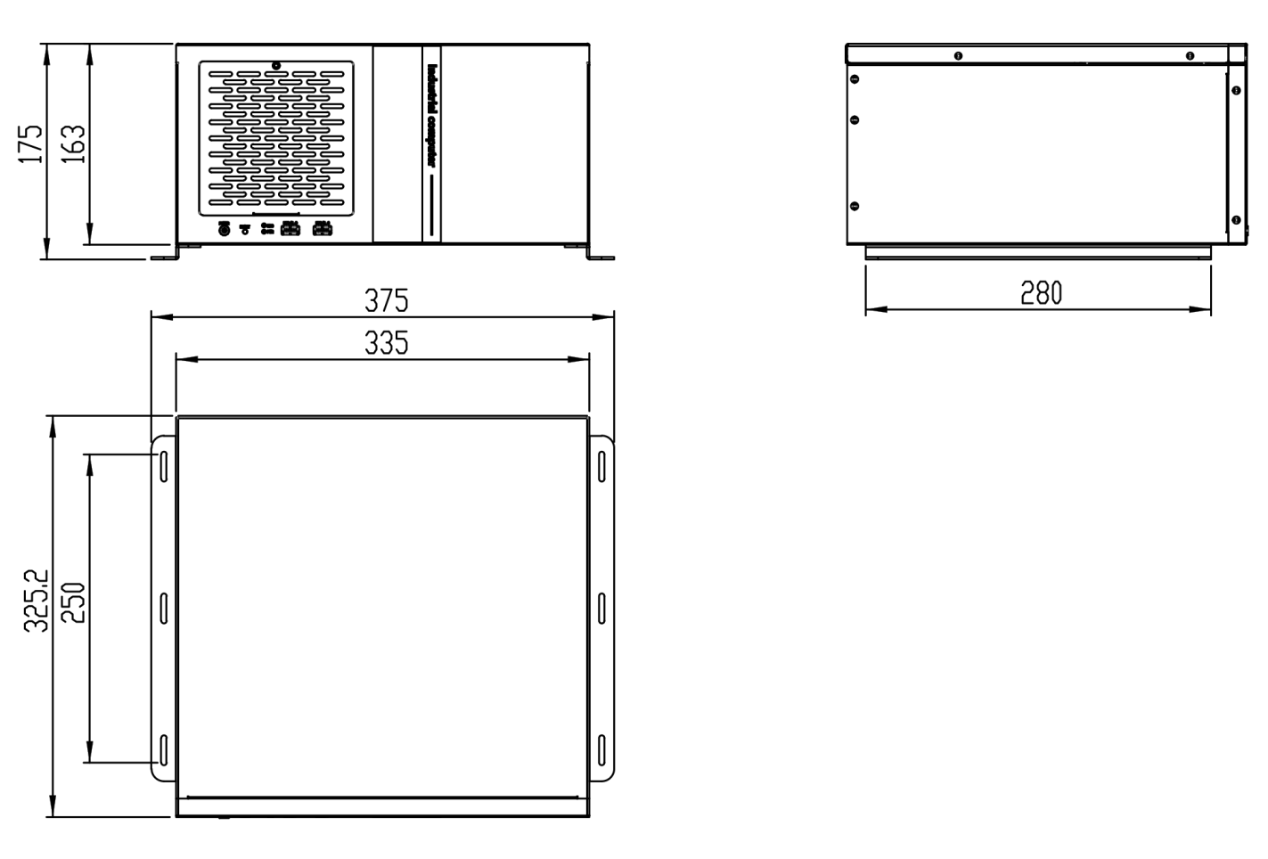
7.Dimensions:

